Information request

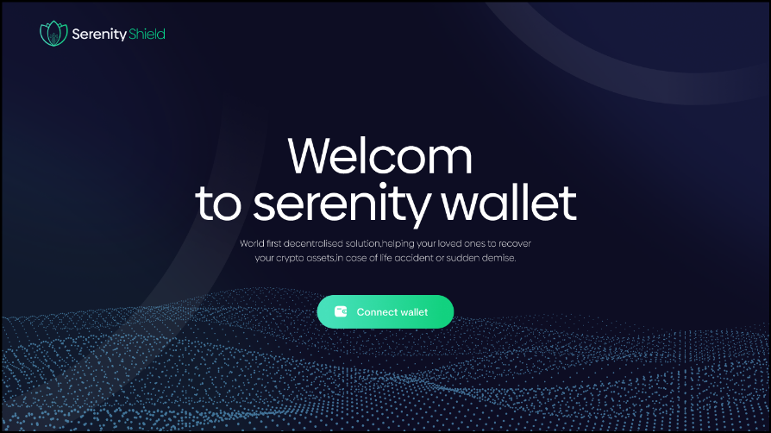

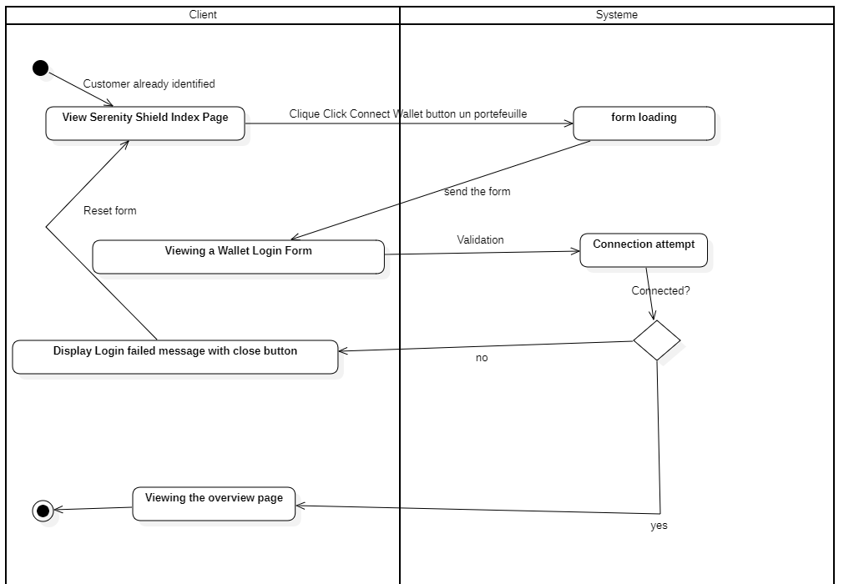

The customer is already logged in so come here to connect their wallet,Once logged in, the customer is on the Overview page.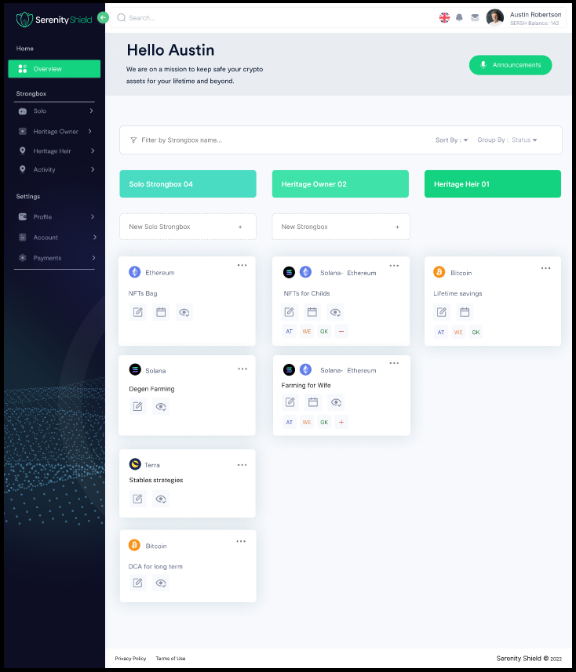

Detailed activity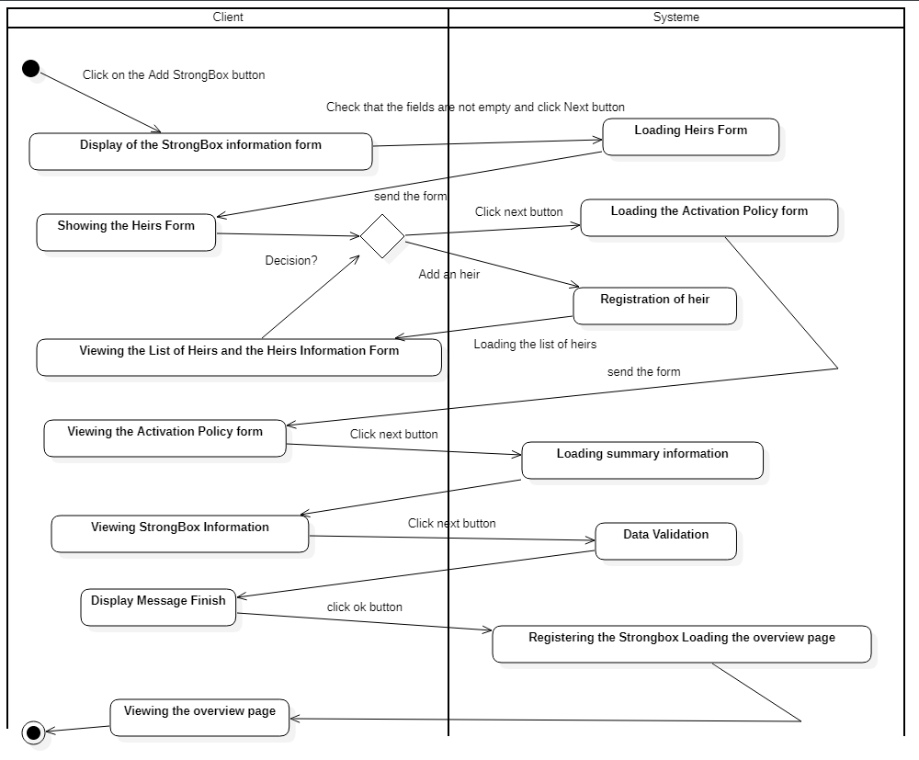

To Build a StrongBox,

the Customer must Click on the New StrongBox button.

The process is done in 4 steps that we detail by activities.

Activity Step 1 Filling in StrongBox information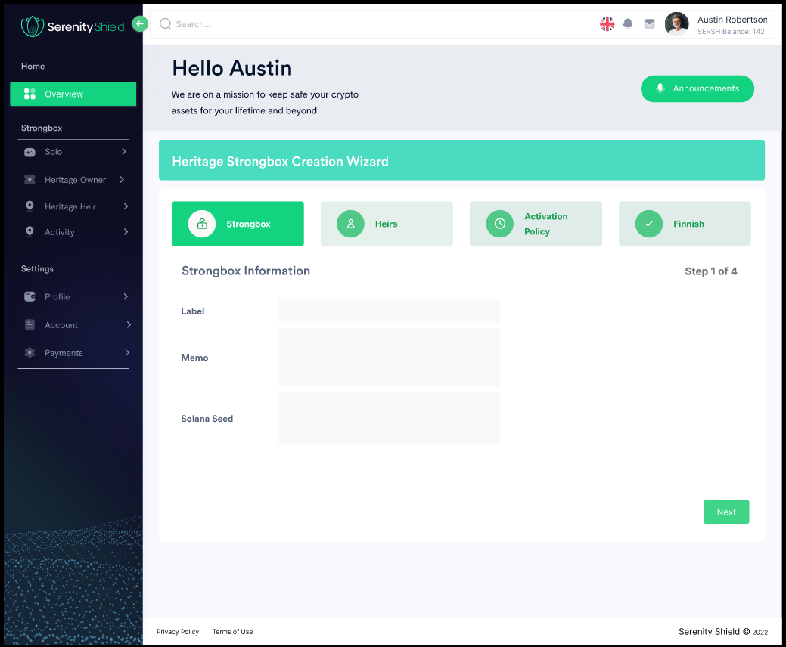

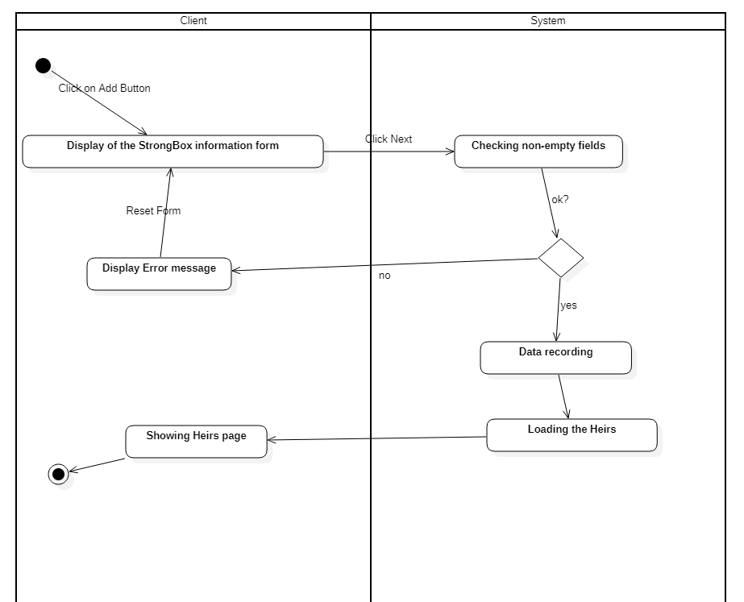

We have 3 fields, do we only need these 3 fields or more?

Activity Step 2 Filling in the information of the Heirs

In this interface we see that we can add only one beneficiary, but we should be able to add several.

I therefore propose an alternative solution where we would have a table containing 3 actions (add, delete, modify) for the management of these multiple rights holders.

In addition, we are missing information, what is it? (surname, first name, email address, etc.)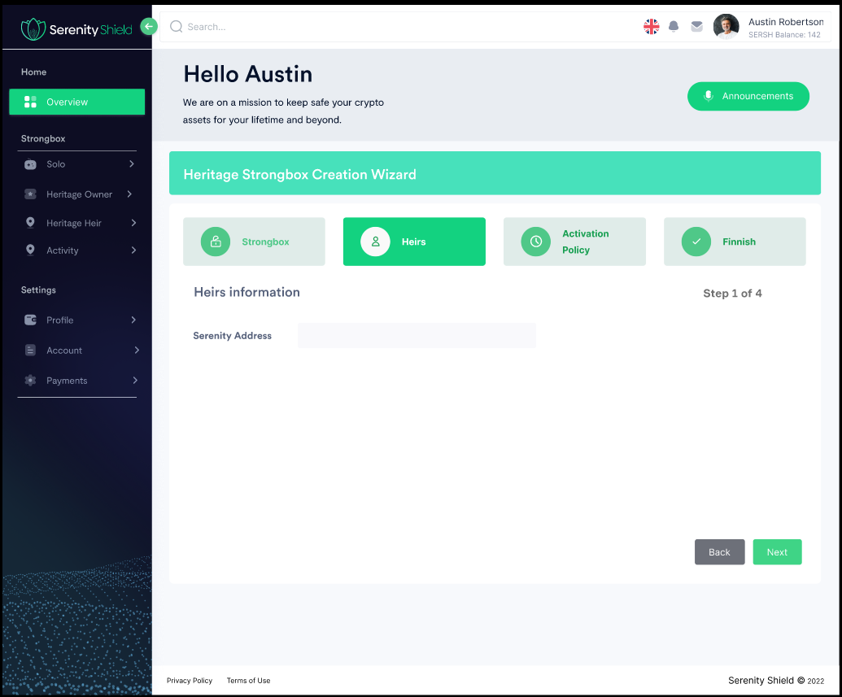

This diagram illustrates the logical operation of the addition.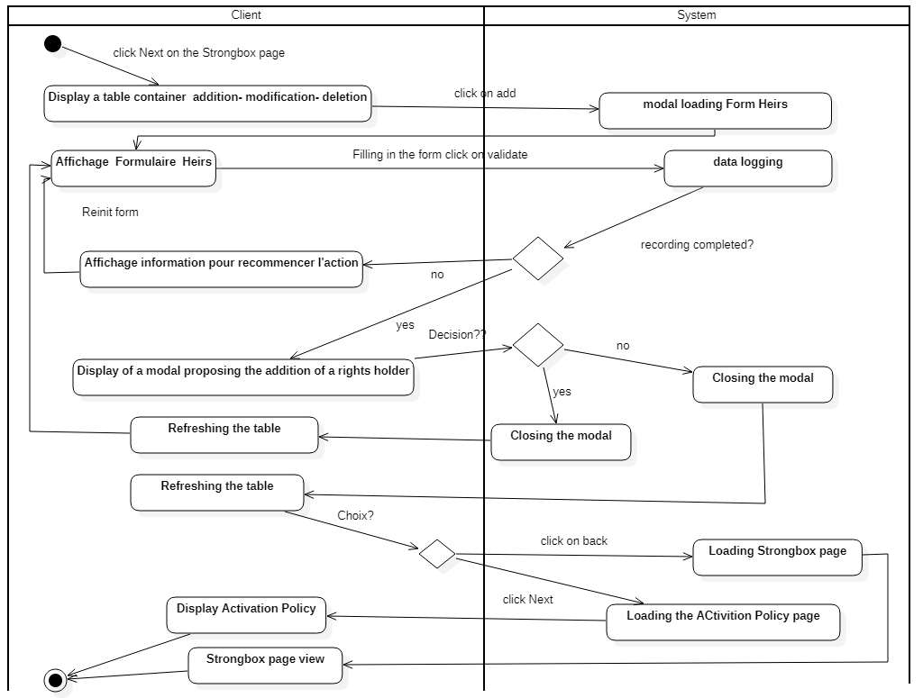

This diagram illustrates the update.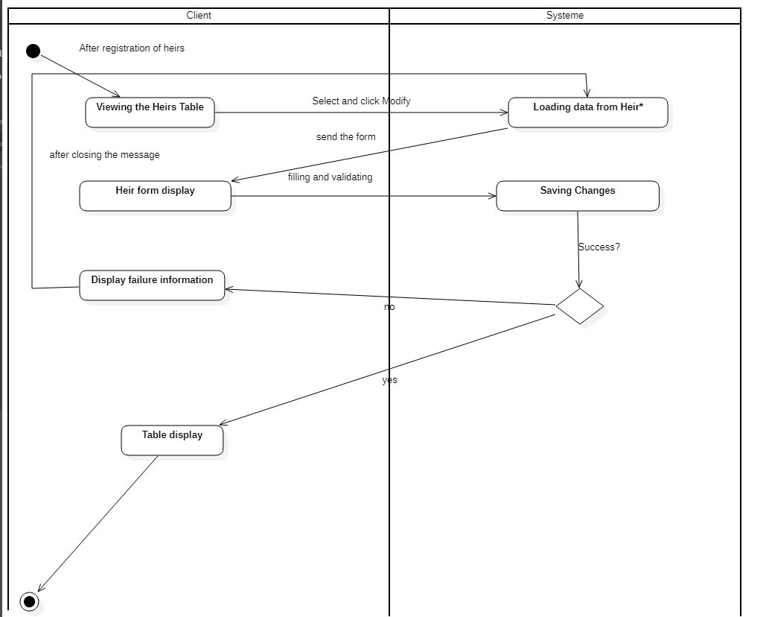

This diagram illustrates the removal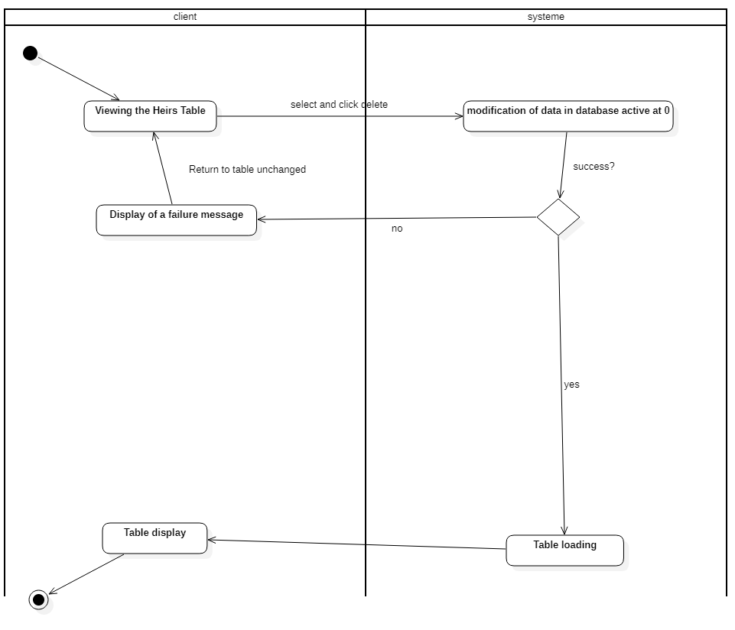

Activity Step 3 Activation rules

In this case the question is “Do we have enough information?” »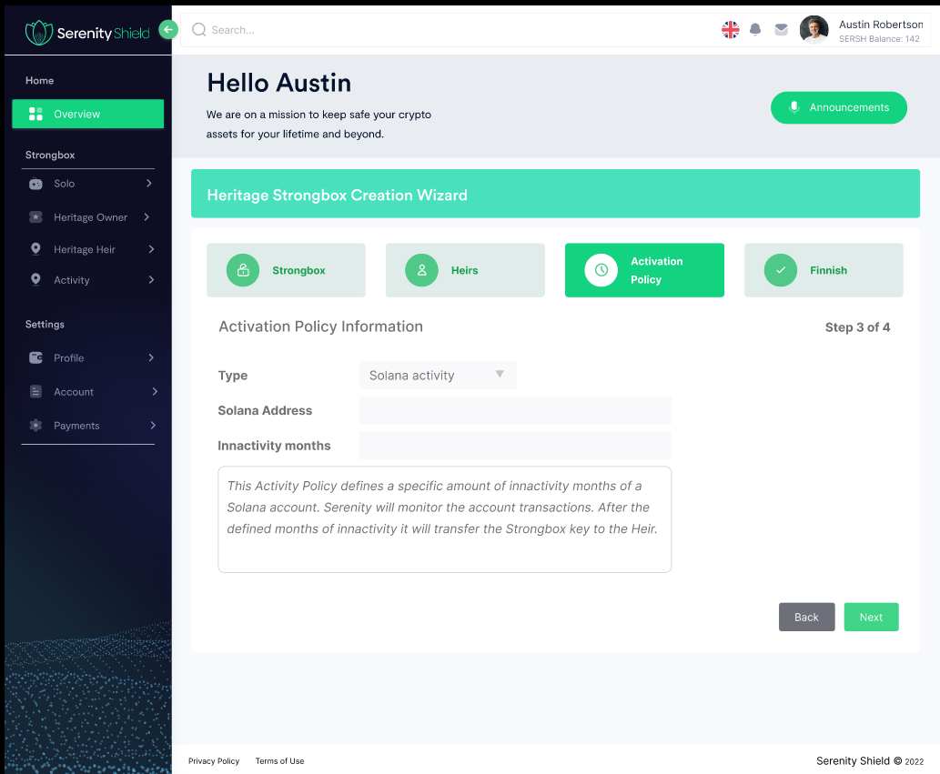

Diagram illustrating this phase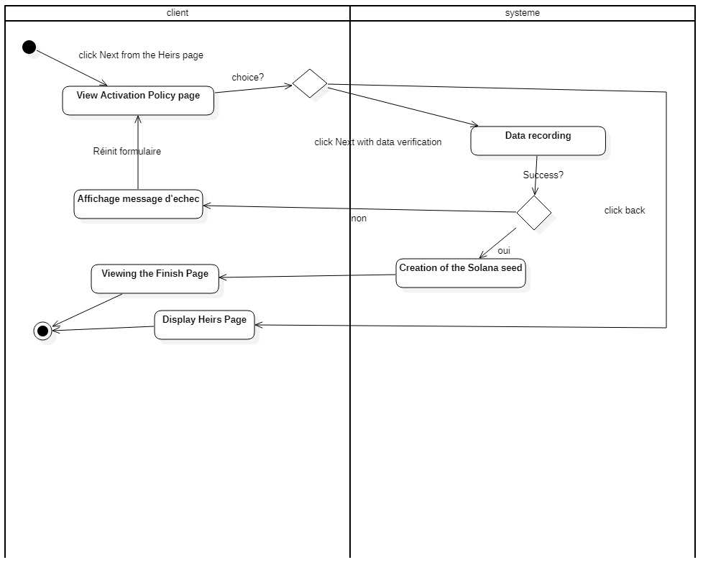

Here we have a dark side, because when recording information, we must create a Solana seed. So Who create it and how?

Activity Step 4 Finalization

In this last activity, we have the summary of past actions.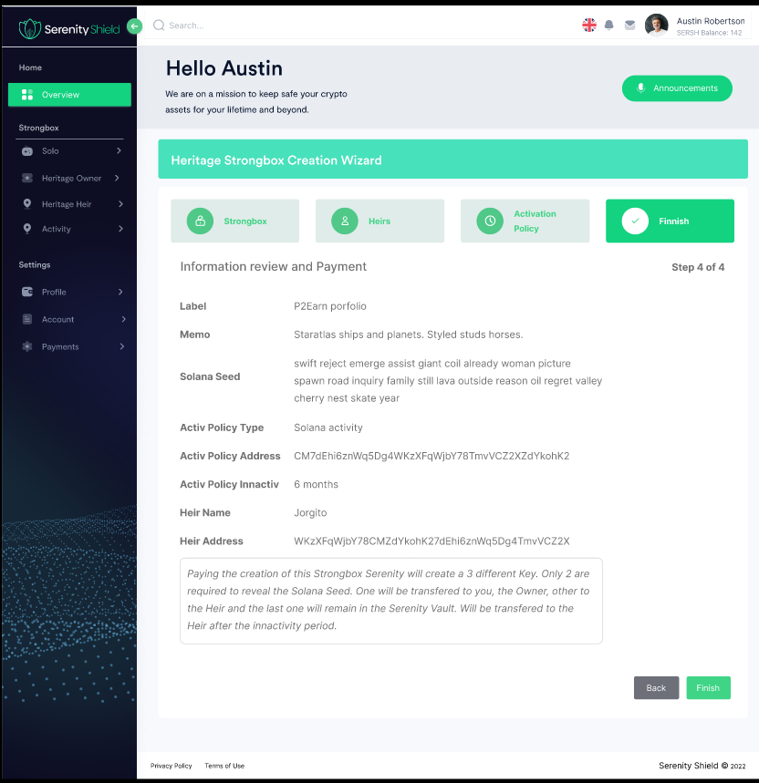

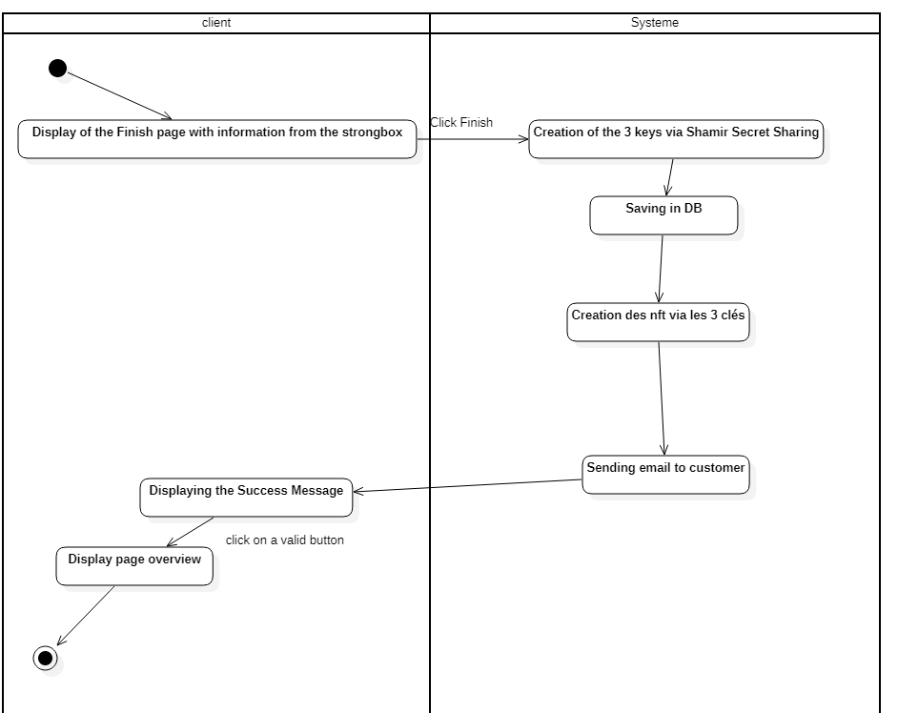

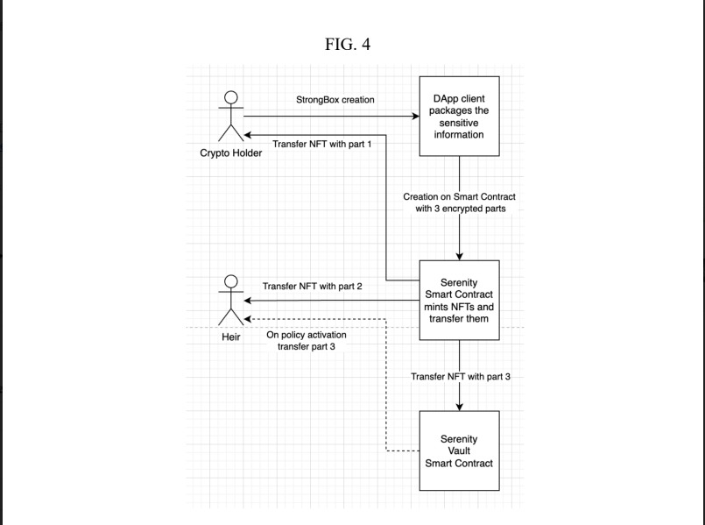

Based on the diagrams above,

The seed is split into 3 keys via the Shamir Secret Share system and then with these keys the NFTs are generated.

There will therefore be a round trip between the creation of the seed and the return of the three keys for the creation of the NFTs and then the sending by email.

Do the NFTs once created have the same key as at the start?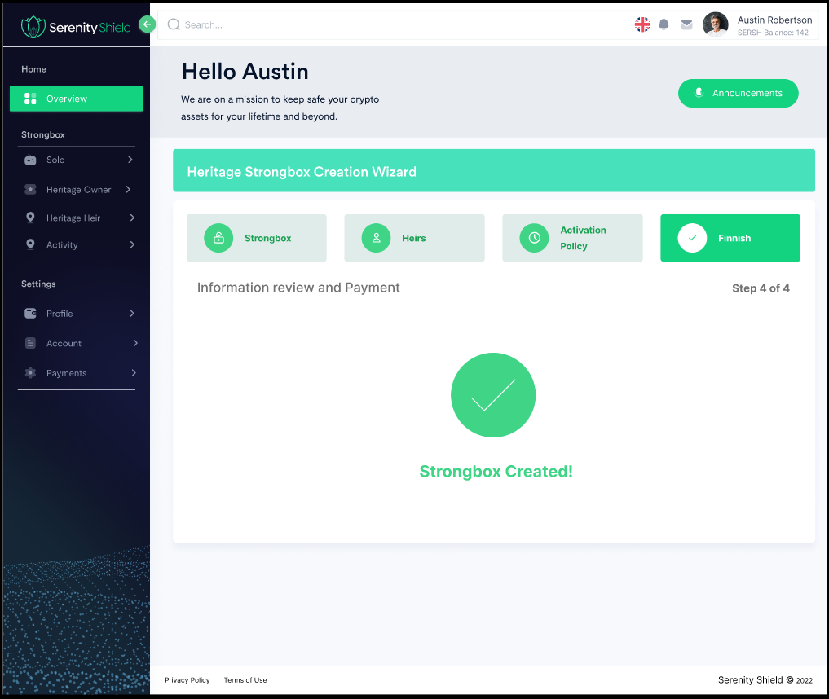

On this Interface we lack an action button to return to the Overview page.

Click on Solo

We should have a page with only Strongbox Solo

Here again, information is missing, we have seen the creation of the strongbox but rules are missing.

We can see in some the right to modify to see and I suppose that the calendar gives the right to edit the activation Policy and other only the modification and the view.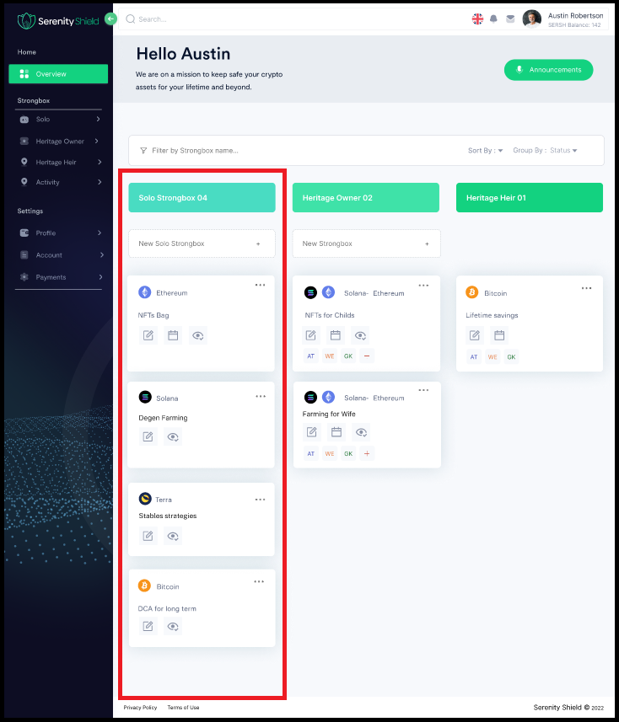

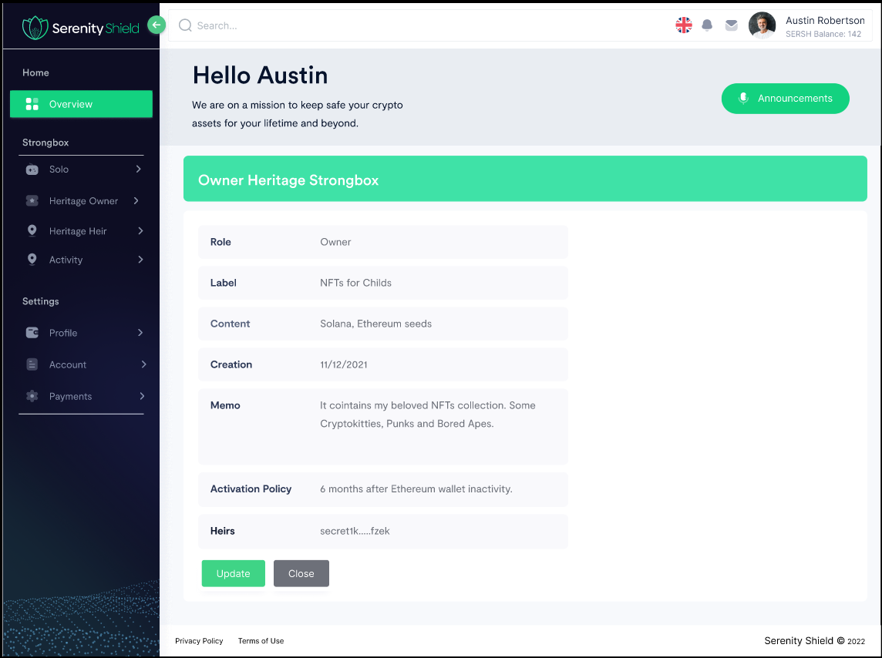

Here we are missing the modification interface.

Click on Heritage Heir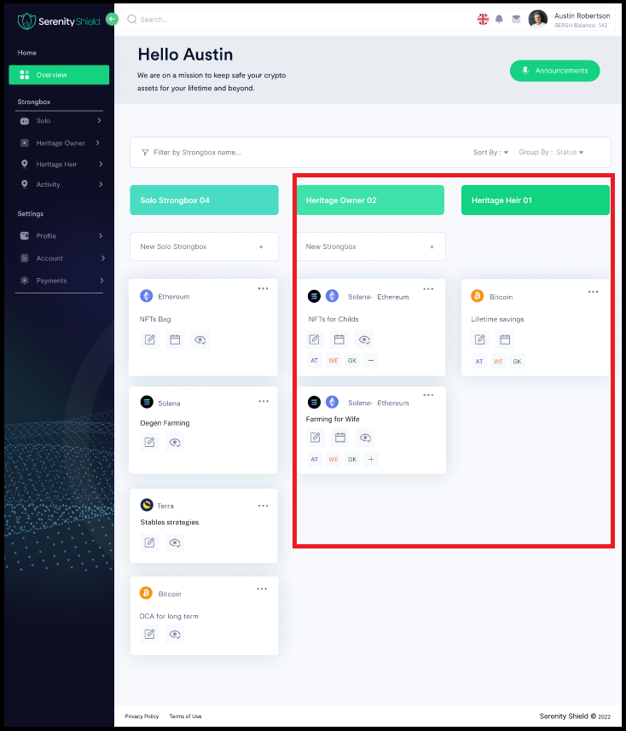

We should have a page with only Strongbox Heir

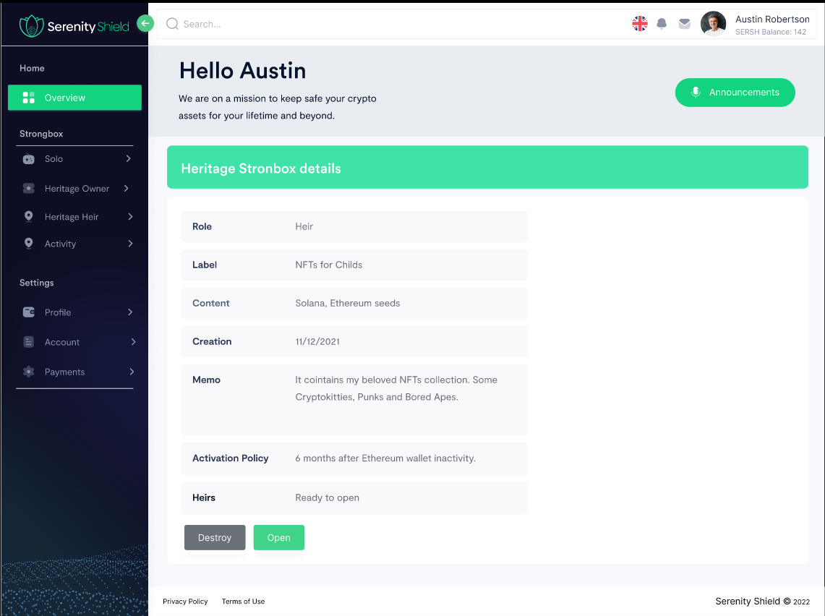

Click on open us the bottom view

The destroy button actually destroys the StrongBox?

What happens to the Created NFTs?

Can you destroy an NFT from the blockchain?

From the Database point of view, we can deactivate it or delete it completely according to our needs.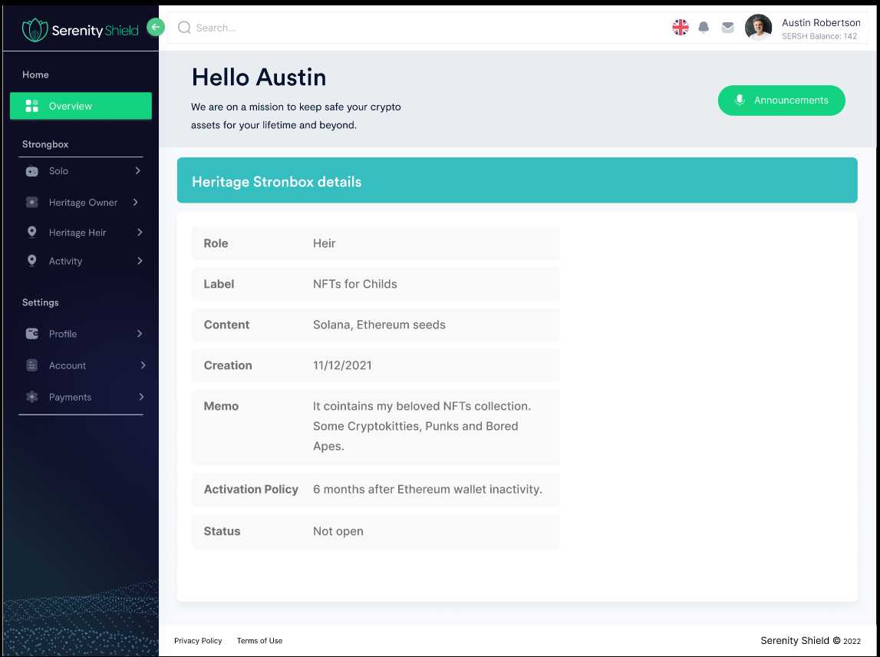

I don't know where and when this interface is used.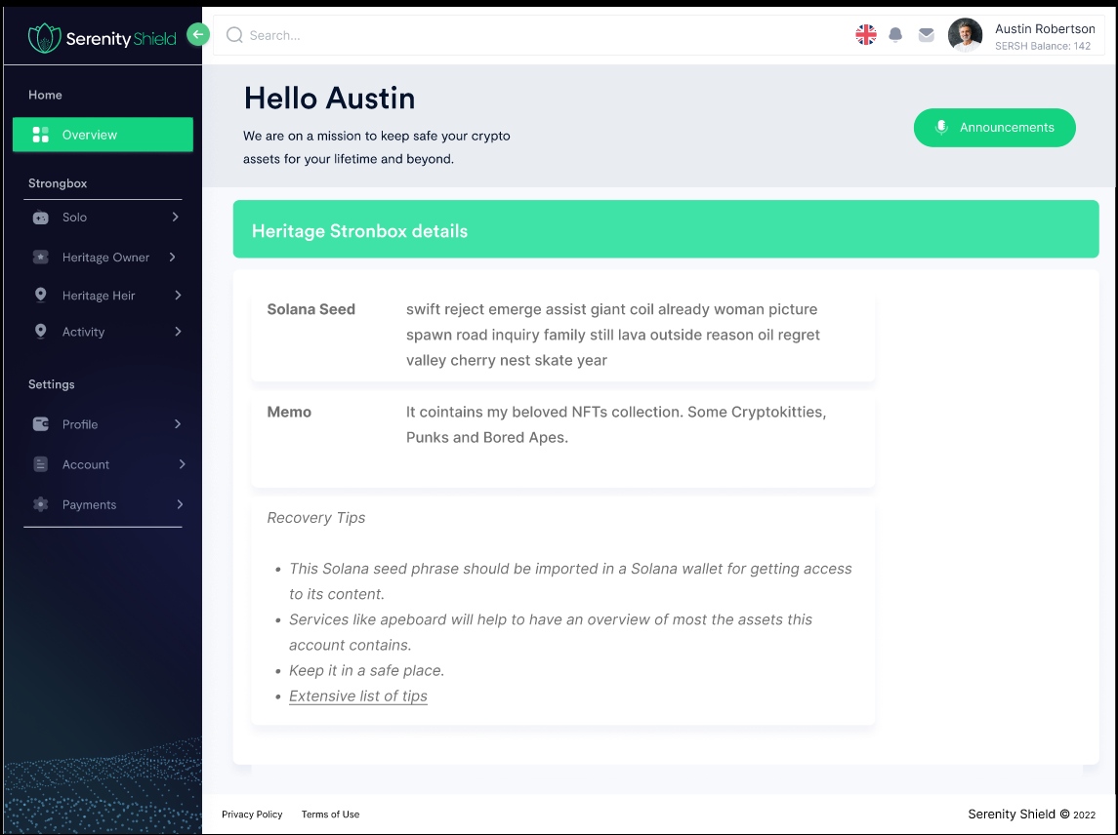

Clique sur Activity

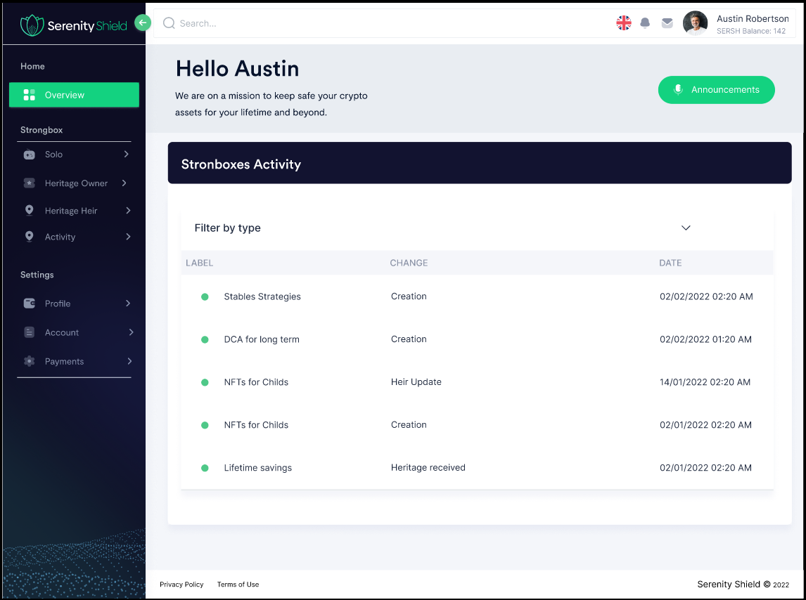

Logging of customer actions on their account.

Possible via database but

Is this possible via the blockchain?